JPO 152 Additional Physics
Class Test 3B : 3 May 2013
Surname: Student Number: Total: /20
Question 1 [9]
A 60kg Skier starts from rest at a height $H=20 m$ above the end of a ski-jump ramp and leaves the ramp at angle $θ=28°$. You may neglect the effects of air resistance
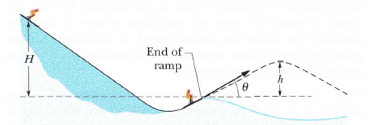
- Calculate the maximum height h achieved by the skier (6)
The skier starts at rest y = 20 m above the point of “launch” so energy conservation leads to
$$E_{mech,i}=E_{mech,f}$$
$$mgH=\frac{1}{2}mv^{3}⇒v=\sqrt{2gH}=19.8 m/s$$
which becomes the initial speed v₀ for the launch. Hence, the above equation relating h to v₀ yields
$$h=\frac{{\left(v_{o}\sin{28°}\right)}^{2}}{2g}=4.41 m$$

- If the skier’s mass was greater, then would h increase, decrease or remain the same? Explain (3)
Remains the same. The velocity with which the skier leaves the ramp is independent of the mass of the skier. Hence the maximum height reached will also be the same

Question 2 [8]
The diagram below shows a composite slab constructed from equal volumes of iron (density = $7.85 g/{cm}^{3}$) and aluminium (density = $2.70 g/{cm}^{3}$)
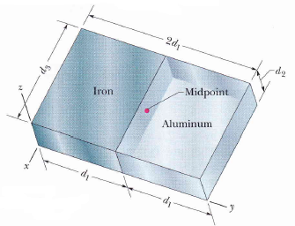
The dimensions of the slab are $d_{1}=11.0 cm, d_{2}=2.80 cm$ and $d_{3}=13.0 cm$
Find the centre of mass of the slab
By symmetry $x_{com} = –d_{1}/2 = –(13 cm)/2 = – 6.5 cm$. The negative value is due to our choice of the origin.
We find $y_{com}$ as
$$y_{com}=\frac{1}{M}\sum{m_{i}y_{i}}=\frac{1}{M}\sum{ρ_{i}V_{i}y_{i}}=\frac{ρ_{iron}V_{iron}y_{iron}+ρ_{aluminium}V_{aluminium}y_{aluminium}}{ρ_{iron}V_{iron}+ρ_{aluminium}V_{aluminium}}$$
$$=\frac{ρ_{iron}y_{iron}+ρ_{aluminium}y_{aluminium}}{ρ_{iron}+ρ_{aluminium}}=\frac{\frac{11}{2}\left(7.85\right)+3\left(\frac{11}{2}\right)(2.7)}{7.85+2.7}=8.3 cm$$
Again by symmetry, we have $z_{com}=(2.8 cm)/2 = 1.4 cm$.

Question 3 [3]
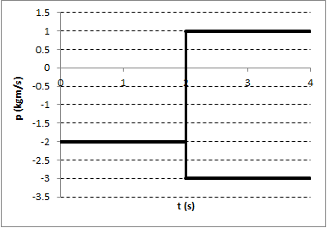
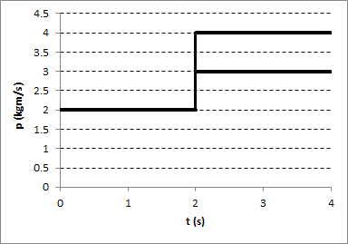
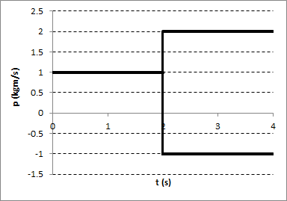
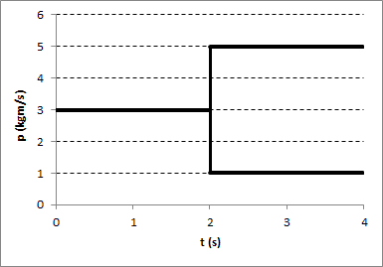
A block and frictionless floor form a closed isolated system. At some stage during the blocks motion it explodes into two pieces. Which of the following graphs representing momentum of the block as a function are physically impossible? Explain your answer
(d)
(c)
(b)
(a)

A and C. In a closed isolated system the total linear momentum must be conserved at all stages. In these two cases $P_{i}≠p_{1}+p_{2}$

Formula Sheet
$$W_{net}=∆E_{k}$$
$$F=-\frac{dE_{p}}{dx}$$
$$W=∆E_{mech}+{∆E}_{th}+∆E_{int}$$
$${\vec{r}}_{com}=\frac{1}{M}\sum{m_{i}{\vec{r}}_{i}^{2}}$$
${\vec{F}}_{net}=M{\vec{a}}_{com}$ ${\vec{F}}_{net}=\frac{d\vec{P}}{dt}$
$$\vec{J}=\int_{t_{i}}^{t_{f}}{\vec{F}\left(t\right)dt}$$

